NAME: LAURA BINFA
PROJECT TITLE: WEEK 3 PROJECT

TASK 1: WORKSTATION AND NETWORK INTERFACE
Hostname: kali
Active network interface name: eth0
IPv4 address: 192.168.145.129/24
MAC address: 00:0c:29:f4:af:50
Default gateway: 192.168.145.2
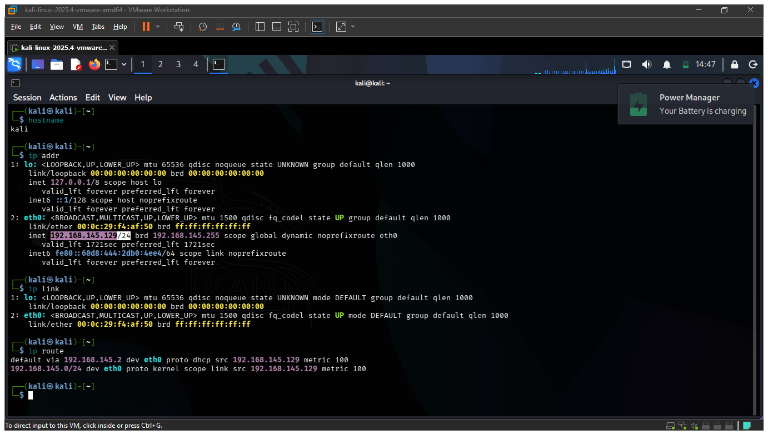

TASK 2: DNS INFORMATION
The DNS information of the workstation was obtained using the resolvectl status command. The command displayed the DNS configuration for the active eth0 network interface. However, no specific DNS server IP address was visible in the output. Therefore, no DNS server address was assumed or guessed.

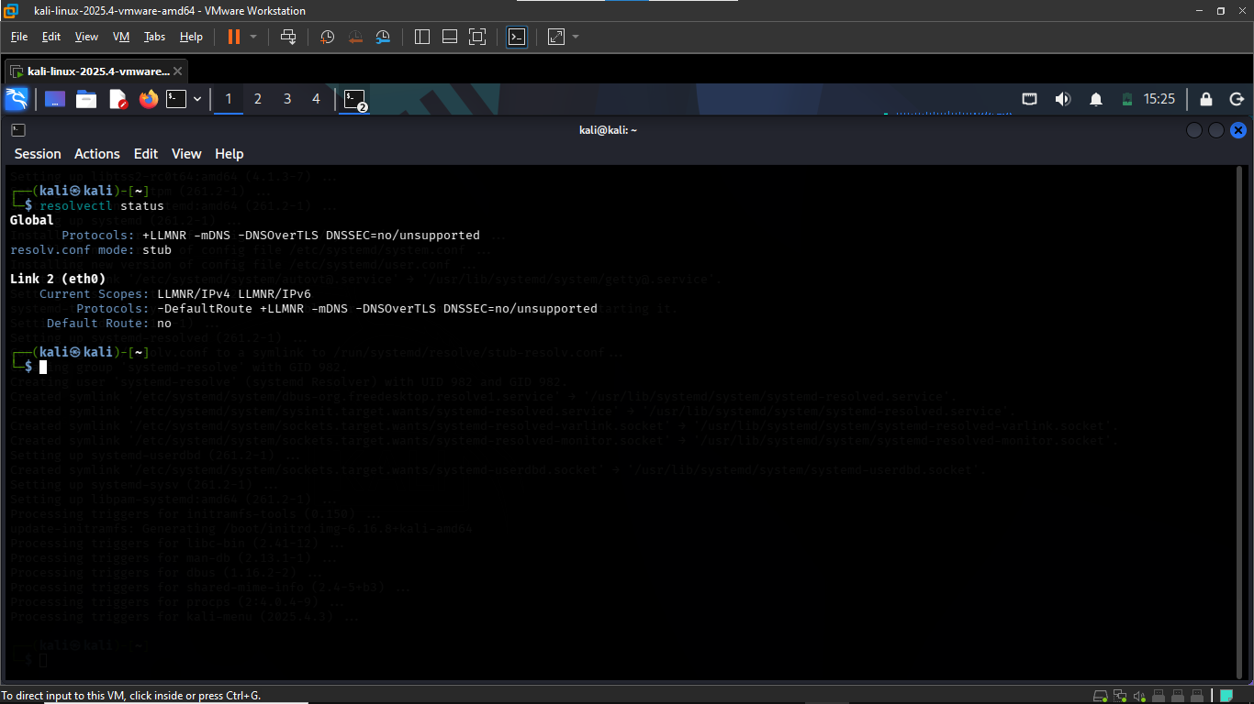

TASK 3: CONNECTIVITY TESTING
TEST | DESTINATION | RESULT | MEANING
Localhost | 127.0.0.1 | Replies received | The workstation can communicate with itself through local network stack.
Default Gateway | 192.168.145.2 | Replies received | The workstation can communicate with the local network gateway.
Instructor approved destination | example.com | Replies received | Placeholder web address used in manuals, guides, and test

TASK 4: DNS LOOKUP
A DNS lookup was performed using the nslookup google.com command. The DNS server used was 127.0.0.53, and the lookup returned several IP addresses for google.com, including 142.251.29.101.

TASK 5: ROUTE INVESTIGATION
The network route to example.com was investigated using tracepath/route-tracing tool. The first visible hop was the default gateway at 192.168.145.2. The subsequent hops did not provide visible replies before the test was stopped. A hop represents a network device routing point that traffic passes through on its way from the workstation toward the destination. The lack of replies from later hops does not necessarily indicate a network failure, since some devices may not respond to route-tracing packets.

TASK 6: WIRESHARK ICMP CAPTURE
Wireshark was used to capture ICMP traffic generated by the workstation. The ICMP display filter was applied to identify ICMP echo request and echo reply packets.
Packet number | Source IP | Destination IP | Protocol | Type
43 | 192.168.145.129 | 192.168.145.2 | ICMP | Echo request
44 | 192.168.145.2 | 192.168.145.129 | ICMP | Echo reply

The Echo request was sent from the workstation to the default gateway, and the Echo reply was received from the default gateway. This shows the ICMP request and response traffic between the workstation and the gateway. 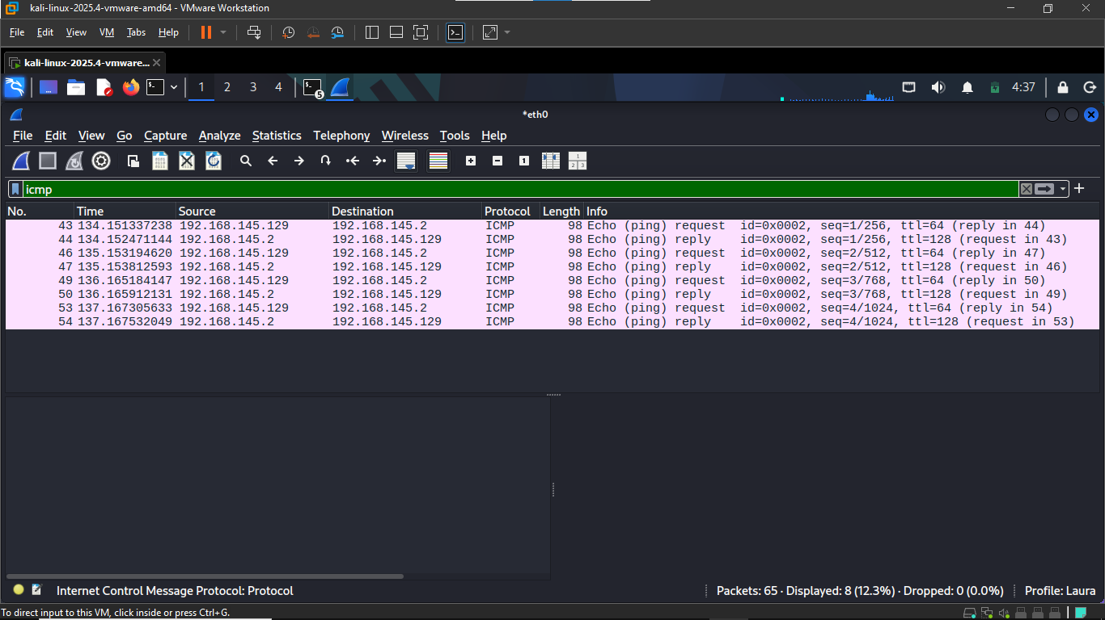

TASK 7: WIRESHARK DNS CAPTURE
Wireshark was used to capture DNS traffic generated by the workstation. The dns display filter was applied to identify the DNS query and response for google.com
ITEM | DETAILS
Source IP | 192.168.145.129
Destination IP | 192.168.145.2
Requested domain | google.com
Query type | A
Returned IP address | 142.250.117.138

TASK 8: NETWORK DIAGRAM
Workstation:
IP: 192.168.145.129

REMOTE SERVER
INTERNET
router/ default gateway
192.168.145.2
WI-FI/ Switch
Access point

SECURITY OBSERVATION AND REFLECTION
- An IP address identifies a device on a network and allows data to be sent to and from that device.
- An IP address is used to identify a device on a network, while a MAC address identifies the network interface of a device.
- The default gateway provides a path for the workstation to communicate with devices outside its local network
- DNS translates to domain names such as google.com into the IP addresses that computers can use to communicate with the destination
- A failed ping does not always mean that a device or network is offline because some devices or networks may block or ignore ICMP traffic.
- Wireshark showed the ICMP echo request sent from my workstation (192.168.145.129) to the default gateway (192.168.145.2) and the echo reply sent back to my workstation.
- I observed a DNS query from my workstation to the DNS server for google.com. The DNS response returned IP addresses associated with the domain, including 142.250.117.138
- Cybersecurity analyst inspect network traffic to understand how devices communicate and to identify unusual or potentially suspicious network activity.
- Packet captures can contain sensitive information about network communications. Therefore, capturing traffic should only be performed on systems and networks where permission has been given.
- The most useful concept was how DNS works. I learned that DNS connects human readable domain names to IP addresses and was able to observe this process directly using nslookup and Wireshark.

CONCLUSION
The project provided me with basic traffic analysis and network discovery. I learned how to identify network configuration details such as the workstation IP address and the default gateway. I also used Wireshark to observe ICMP and DNS traffic and identify the communication between my workstation and the network. Overall, this project improved my understanding on how devices communicate with each other on a network and the importance of observing network traffic in cybersecurity.

